**Week 8**

**3.Git-HOL HandsOn**

*First creating a file in the master branch with some content:*







**Branching**

1. 
2. 
3. 









1. 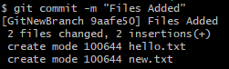
2. 

**Merging**

1. 
2. 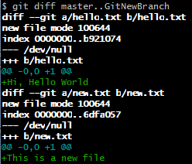

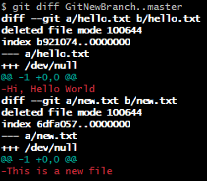

1. 
2. 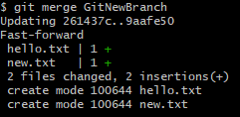
3. 
4. 

